Unity Bootcamp - Creating a 2D Game

Part 3 - Lives and a game timer

# 

# GameManager

It’s time to create a Game Manager that handles player lives and a game timer. Lucky for you I coded it last night, so you don’t have to.Start by importing the ***GameManager*** script into the project.

In *Level1*, create a new *Empty GameObject* by right clicking in the *Hierarchy*, then pressing ***Create Empty***.

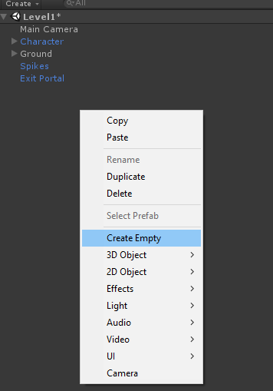

In the inspector, rename it to Game Manager and add the *Game Manager* component to the object (same as adding the other scripts).

Tweak the *Starting Lives* and *Time to Win* values if you like. Ignore the sound variables for now.

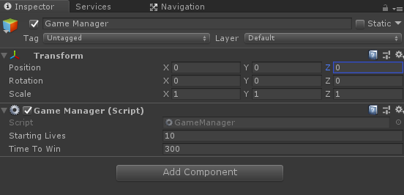

Now make the Game Manager a prefab.

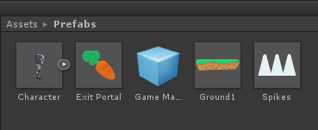

*Tip:* If you make changes to a prefab in the *hierarchy*, for example changing the starting lives on the *Game Manager*. Make sure you press ***Apply*** in the inspector.

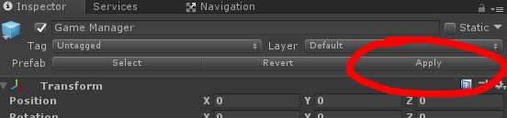

# 

# Time to code! :)

The win and death scripts need to be updated now that you have a Game Manager in the scene.

Firstly open the *DeathZone.cs* script and replace line 11 with the following:***GameManager.Instance.Death();***

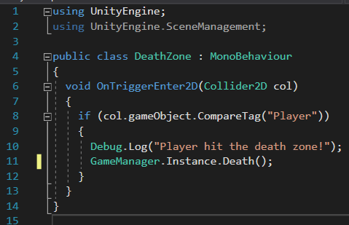

And in *ExitPortal.c*s, replace line 10 with:

***GameManager.Instance.NextLevel();***

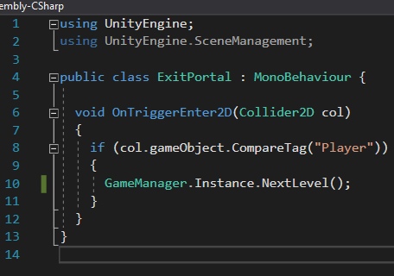

Now, instead of these scripts loading the level themselves, they tell the *Game Manager* that the player has triggered them, and the *Game Manager* handles what happens (in our case: taking away lives or moving onto the next level).

# Play test some more

Now play your game, you’ll see lives and a timer in the top left corner of the screen. If you die with no lives left or run out of time, the game will restart from the very first scene.